**Homework 5 Jupyter Notebooks and Live Data**

Let’s use your container from lab 4 and pull in some “Live” data. You will want to start your data science container and go into Jupyter in the browser. Code will be in red to make it easy to recognize.

(If you have forgotten how to set up your container, just look back at the last lab or try some suggestions below)

*The easiest way to start a container is to go into the docker desktop program and start the existing one your created . Then remember to double click on the container name in desktop to see the command line and get the 127…. url to long on.*

*You can also start the container in command line by typing “docker start - i “ and the name of your container. You can check the name of your containers with “docker container ls –a” or looking in the docker app on your computer.*

If you really get stuck with the container setup, this lab can be done using the online jupyter notebooks.

<https://jupyter.org/try> (Use the classic Notebook)

1. Now let’s pull in some data. We are going to start pretty simple with some csv formatted data. CSV is a file with the data separated by commas. For example you can save an excel file as csv data.
   1. First let’s import the libraries we will need for working with this data. Libraries just add in some additional tools to Jupyter for our program.

import requests

#This library helps us grab the data from the usgs site

#Run the code

import pandas as pd

#This library helps us read the file we grab from the usgs site

#Run the code

import matplotlib.pyplot as plt

#This library helps us plot the data in a chart

#Run the code

dataEQ =pd.read_csv('https://earthquake.usgs.gov/fdsnws/event/1/query?format=csv&starttime=2021-01-01&endtime=2021-01-02&minmagnitude=5', usecols = ['mag'])

print(dataEQ)

#This code grabs the csv file from the usgs site and only includes the magnitude data of the earthquakes #over 5 magnitude for the specific day in the filter.

#Then it prints that data for us to look at.

#Run the Code

plt.plot(dataEQ)

#plots the data

Your screen should now look like the screenshot below.

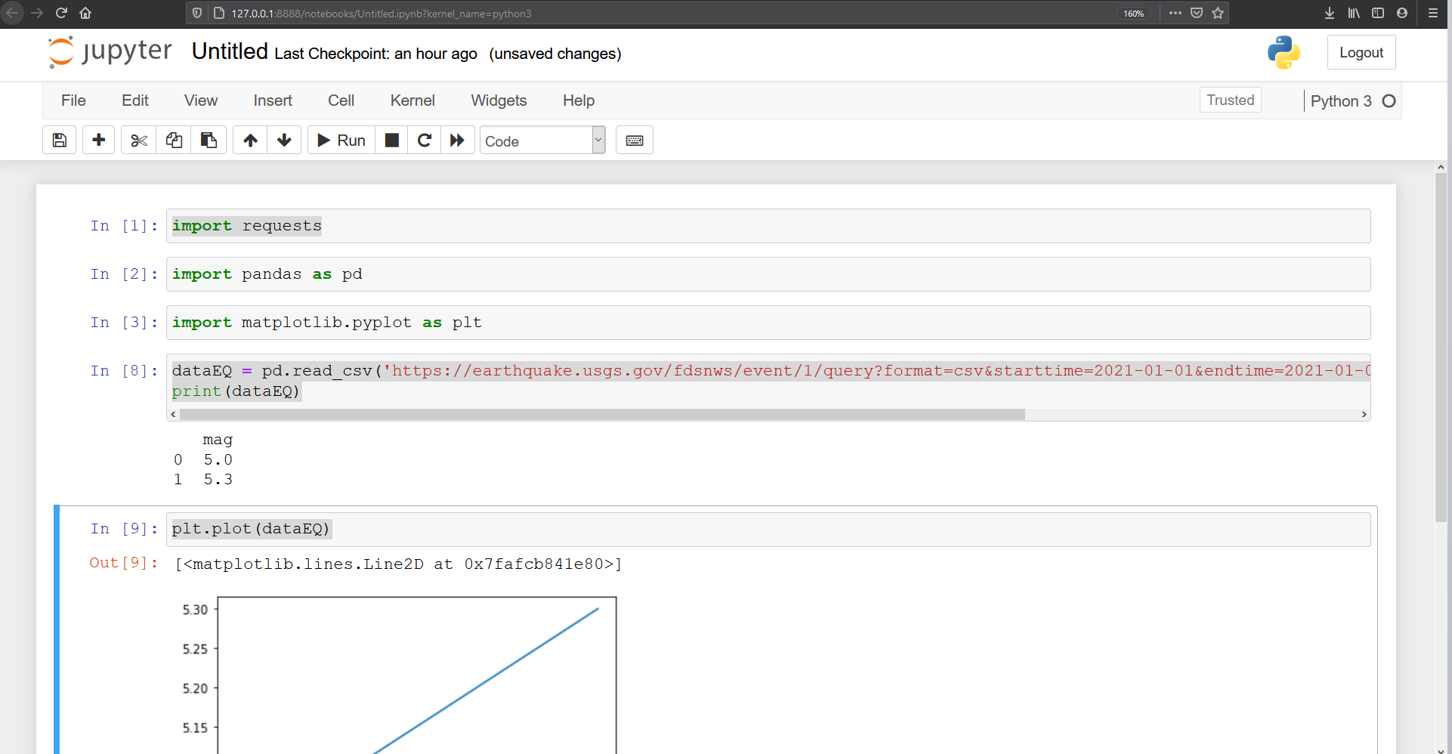

1. So, you should just have 2 earthquakes in your data and displayed on your chart for January 1st to January 2nd. One earthquake had a magnitude of 5.0 and the other 5.3. This is okay for teaching purposes but it isn’t very interesting. Our data query to the USGS had a filter of earthquakes with a magnitude of 5.0 or greater. Let’s work on changing those filters to find out some useful information.
   1. Change the minimum magnitude of the earthquakes to ‘0’. Look closely at the url to pull the data and you will notice **‘minmagnitude-5’** at the end of the request. Just change the 5 to a 0 to get all of the earthquakes. This will include all of the Earthquakes over the two day period. How many earthquakes did you find over that period.?
   2. Graph those magnitudes and provide a screen shot as well. (You will have to figure out how to update the graph by running that snippet of code) Write down some observations that can be gleamed from the chart about the magnitude data.
2. Now lets do some analysis for the depth of those earthquakes over the 48 hours. So we have to change to query to the depth column.

dataEQ =pd.read_csv('https://earthquake.usgs.gov/fdsnws/event/1/query?format=csv&starttime=2021-01-01&endtime=2021-01-02&minmagnitude=0', usecols = ['depth'])

print(dataEQ)

Then you just have to update the chart snippet again or copy and paste the code into a new column to keep both charts.

Provide a screen shot of you depth chart and include your basic observations of the data.